SUPERSTORE SALES DASHBOARD – DOCUMENTATION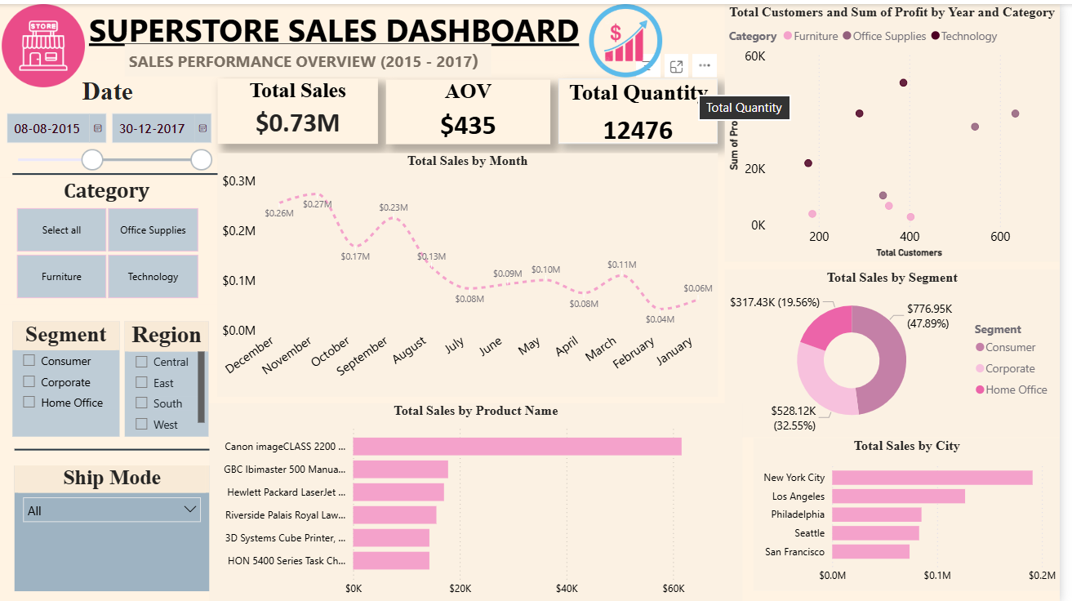

1. Introduction
This Power BI dashboard is created using the Superstore Sales dataset covering the period from 2015 to 2017. The dashboard provides a clean and structured view of sales performance, customer segments, product contribution, and sales trends. It helps in understanding business performance through visual analysis.

2. Objective of the Dashboard
- To analyze overall sales performance
- To identify month-wise sales trends
- To compare sales across categories, segments, and regions
- To identify top-performing products and cities
- To support basic business decision-making

3. Dataset Overview
The dataset contains information such as Order Date, Sales, Quantity, Product Category, Customer Segment, Region, City, and Ship Mode. Basic data cleaning and transformation were carried out using Power Query to ensure accuracy.

4. DAX QUERIES USED
1) IF
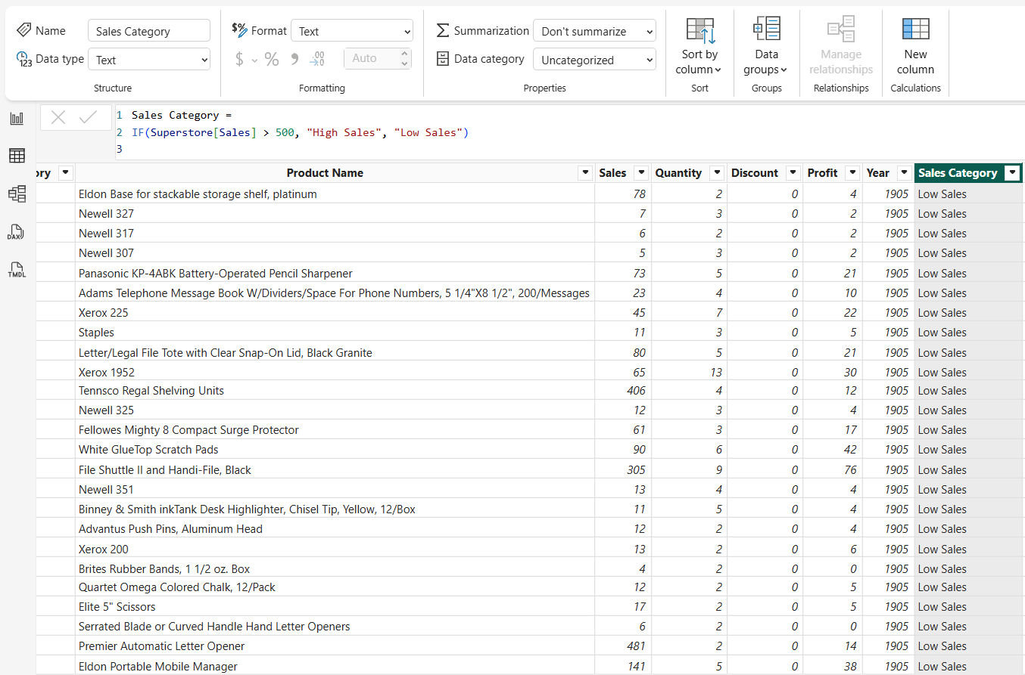
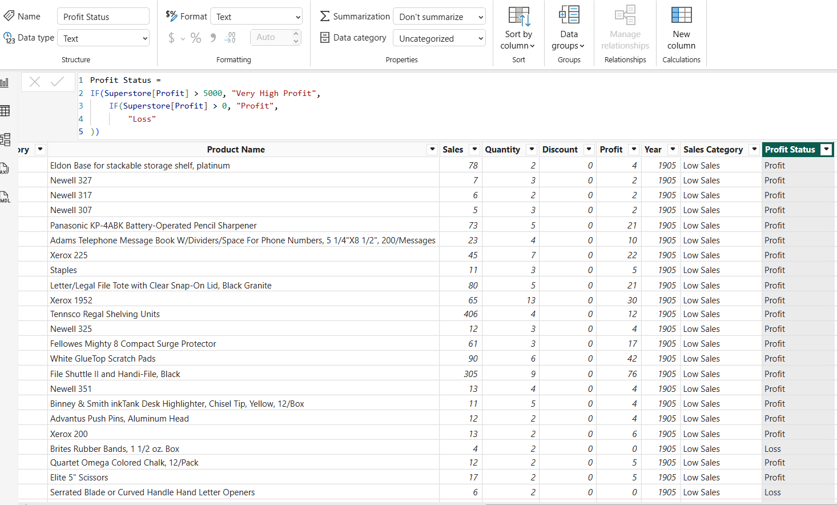
2) COUNT
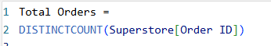
3) SUM


4. Key Performance Indicators (KPIs)
Total Sales: Represents total revenue generated from all orders. DAX Used: SUM(Sales)
Average Order Value (AOV): Represents average revenue per order. DAX Used: Total Sales / Total Orders
Total Quantity: Represents total number of items sold. DAX Used: SUM(Quantity) 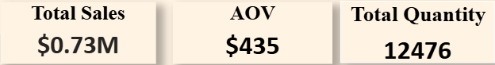

5. Filters and Slicers
The dashboard includes slicers for Date, Category, Segment, Region, and Ship Mode. These slicers allow users to filter data dynamically and analyze sales from different perspectives.

6. Visual Analysis
- Monthly Sales (Line Chart): Displays month-wise sales trends and seasonal patterns.
- Product-wise Sales (Bar Chart): Shows top-performing products based on total sales.
- City-wise Sales (Bar Chart): Compares sales across different cities.
- Segment Contribution (Donut Chart): Displays percentage contribution of each customer segment. Customers vs Profit (Scatter Plot): Shows the relationship between customer count andprofit.

- Customers vs Profit (Scatter Plot): Shows the relationship between customer count andprofit.

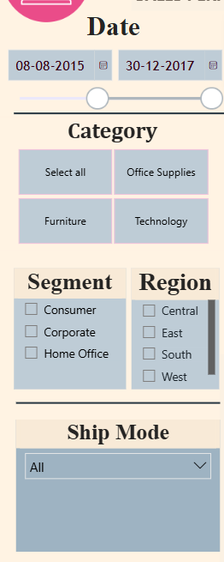

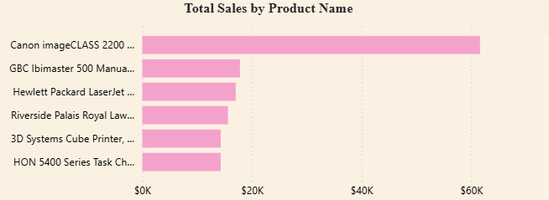

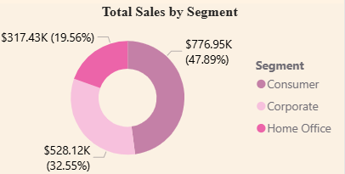

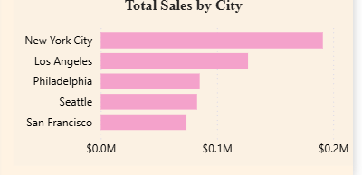

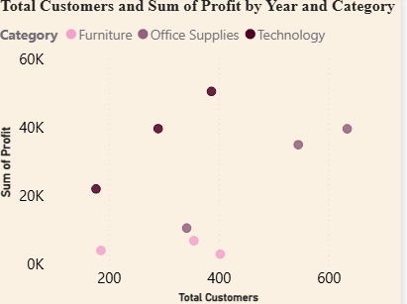

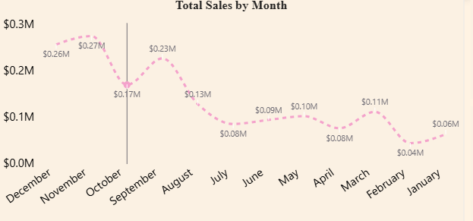

7. Insights and Findings
- Sales increase during year-end months.
- The Consumer segment contributes the highest share of sales.
- Technology products generate better profitability.
- Major cities contribute higher revenue.

8. Conclusion
This Power BI dashboard provides a balanced, clean, and professional analysis of sales data. It effectively summarizes key metrics and trends, making it suitable for academic evaluation and basic business analysis.

